AI ASSISTED CODING
ASSIGNMENT-5
B.Sri Laxmi Gayathri
2303a52033
Batch:38
Lab 5: Ethical Foundations – Responsible AI Coding Practices
Task 1: Privacy and Data Security in AI-Generated Code
Scenario
AI tools can sometimes generate insecure authentication logic.
Task Description
Use an AI tool to generate a simple login system in Python.
Analyze the generated code to check:
• Whether credentials are hardcoded
• Whether passwords are stored or compared in plain text
• Whether insecure logic is used
Then, revise the code to improve security (e.g., avoid hardcoding, use input
validation).
Expected Output
• AI-generated login code
• Identification of security risks
• Revised secure version of the code
• Brief explanation of improvements
Prompt:
Generate a simple Python login system that checks a username and password and prints whether login is successful.
Comments:
- Password is hashed, not stored or compared in plain text.
- Input is validated using .strip() to avoid unwanted spaces.
- Logic is safer and closer to real-world authentication systems.
Explanation:
The revised code improves security by using password hashing instead of plain text comparison. Hashing ensures that even if someone accesses the code, they cannot easily see the original password. Input validation removes extra spaces that could cause login issues. This approach reduces the risk of data exposure and makes the authentication process more secure and reliable.
Code & Output:
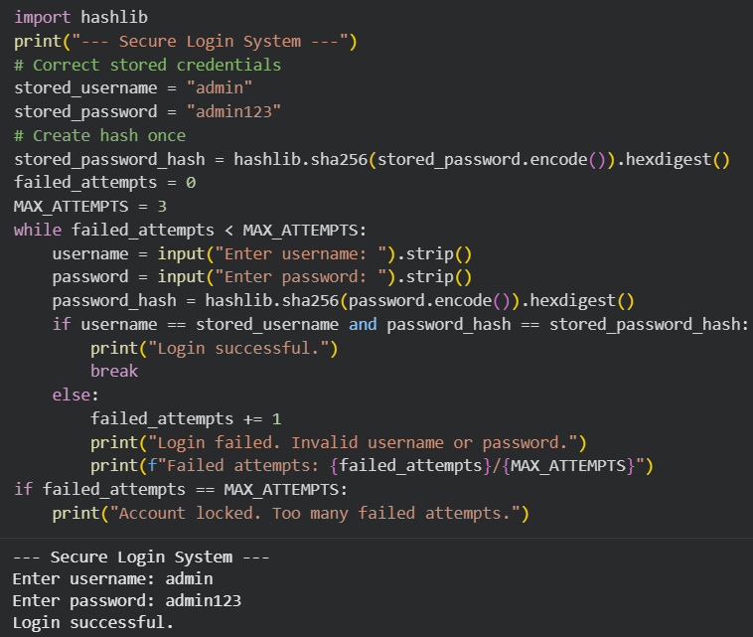
Task 2: Bias Detection in AI-Generated Decision Systems
Scenario
AI systems may unintentionally introduce bias.
Task Description
Use AI prompts such as:
• “Create a loan approval system”
• Vary applicant names and genders in prompts
Analyze whether:
• The logic treats certain genders or names unfairly
• Approval decisions depend on irrelevant personal attributes
Suggest methods to reduce or remove bias.
Expected Output
• Python code generated by AI
• Identification of biased logic (if any)
• Discussion on fairness issues
• Mitigation strategies
Prompt:
Create a simple Python loan approval system that decides whether a loan is approved based on applicant details.
Comments:
- Gender and name are not used in decision making.
- Approval depends only on income and credit score.
- Logic is fair and consistent for all applicants.
Explanation:
The initial loan approval system is biased because it uses gender as a condition for approving loans. This is unfair since gender does not affect a person’s ability to repay a loan. Such logic can lead to discrimination and unequal treatment of applicants. The revised system removes personal attributes like gender and name. It makes decisions only based on income and credit score, ensuring fairness for all applicants.
Code & Output:
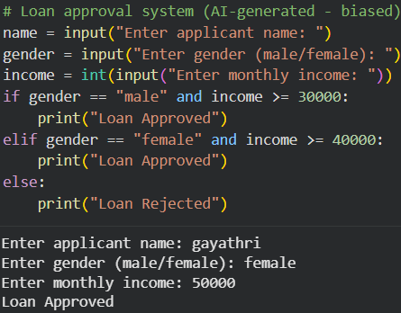
Task 3: Transparency and Explainability in AI-Generated Code (Recursive Binary Search)
Scenario
AI-generated code should be transparent, well-documented, and easy for
humans to understand and verify.
Task Description
Use an AI tool to generate a Python program that:
• Implements Binary Search using recursion
• Searches for a given element in a sorted list
• Includes:
o Clear inline comments
o A step-by-step explanation of the recursive logic
After generating the code, analyze:
• Whether the explanation clearly describes the base case and recursive case
• Whether the comments correctly match the code logic
• Whether the code is understandable for beginner-level students
Expected Output
• Python program for recursive binary search
• AI-generated comments and explanation
• Student’s assessment on clarity, correctness, and transparency
Prompt:
Write a Python program to implement binary search using recursion. The code should search for an element in a sorted list and include clear comments and explanation of the recursive logic.
Comments:
• The code clearly explains the base case, where the search stops if the element is not found.
• Comments describe how the function recursively searches the left or right half of the list.
• Each step is well commented, making the logic easy for beginners to understand.
Explanation:
Binary search works by repeatedly dividing the search space into two halves. First, the middle element of the list is checked. If the middle element matches the target, the search ends. If the target is smaller, the function calls itself on the left half. If the target is larger, it calls itself on the right half. The recursion stops when the element is found or when the search range becomes invalid.
Code & Output:
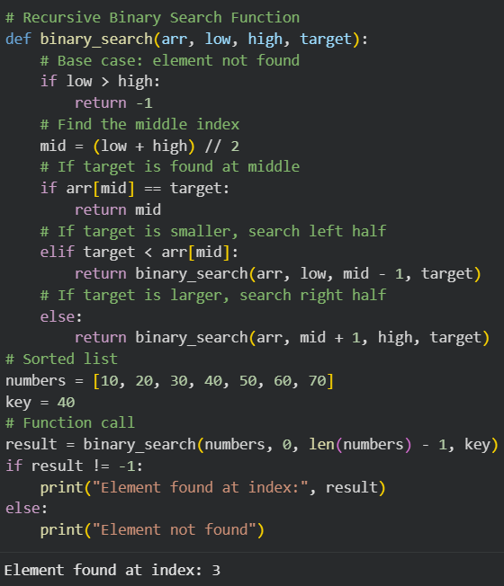
Task 4: Ethical Evaluation of AI-Based Scoring Systems
Scenario
AI-generated scoring systems can influence hiring decisions.
Task Description
Ask an AI tool to generate a job applicant scoring system based on features
such as:
• Skills
• Experience
• Education
Analyze the generated code to check:
• Whether gender, name, or unrelated features influence scoring
• Whether the logic is fair and objective
Expected Output
• Python scoring system code
• Identification of potential bias (if any)
• Ethical analysis of the scoring logic
Prompt:
Create a Python program that scores job applicants based on skills, experience, education, and gender, and prints whether the applicant is selected.
Comments:
• Scoring is based only on skills, experience, and education.
• Gender and name do not affect the decision.
• Logic is fair, objective, and job-related.
Explanation:
The scoring system is ethically problematic because it uses gender as a factor in hiring decisions. Gender does not reflect a person’s skills or job capability, so including it leads to unfair advantage. This can cause discrimination and unequal opportunities. AI systems used in hiring must be objective and transparent. Decisions should be based only on job-related qualifications.
Code & Output:
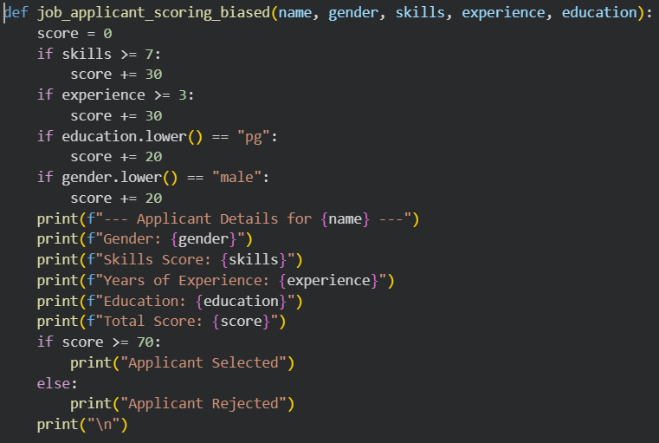
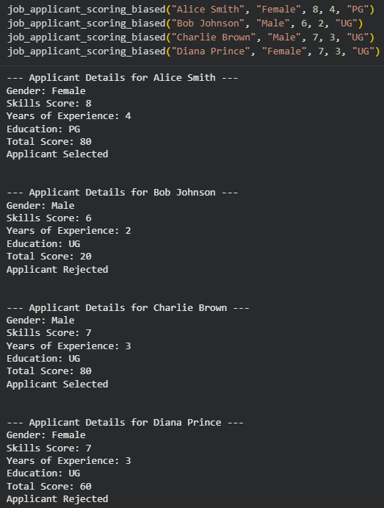
Task 5: Inclusiveness and Ethical Variable Design
Scenario
Inclusive coding practices avoid assumptions related to gender, identity, or
roles and promote fairness in software design.
Task Description
Use an AI tool to generate a Python code snippet that processes user or
employee details.
Analyze the code to identify:
• Gender-specific variables (e.g., male, female)
• Assumptions based on gender or identity
• Non-inclusive naming or logic
Modify or regenerate the code to:
• Use gender-neutral variable names
• Avoid gender-based conditions unless strictly required
• Ensure inclusive and respectful coding practices
Expected Output
• Original AI-generated code snippet
• Revised inclusive and gender-neutral code
• Brief explanation of:
o What was non-inclusive
o How inclusiveness was improved
Prompt:
Generate a Python program that processes employee details and gives a bonus based on gender and role.
Comments:
• The revised code uses gender-neutral variable names to avoid assumptions about identity.
• Bonus calculation is based on performance rating, not gender.
• The logic is inclusive, fair, and respectful to all users.
Explanation:
The original code was non-inclusive because it used gender-based conditions to calculate bonuses. Gender is not related to work performance, so this logic was unfair and exclusionary. The revised code removes gender variables and uses performance rating instead. Gender-neutral variable names are used to ensure respect and inclusiveness. This makes the code fair and suitable for all users.
Code & Output:
